Plants Chapter Test Review
For each pair of terms, explain the relationship between the terms
- Seed: embryo surrounded by a protective case
Spores: reproductive cell surrounded by a hard outer wall,
- Vascular plant: Vascular tissues, true roots and leaves
non-vascular plant: no vascular system, no true roots nor leaves
- Phloem: carries organic compounds
xylem: carries water and dissolved substances
For each pair of terms, explain how the meanings of the terms differ
- Gymnosperm: produce seeds that are nor enclosed in a fruit
Angiosperm: flowering plants that produce seeds that are enclosed in a fruit
- Gametophytes: haploid and produces eggs and sperm
Sporophyte: are diploid and produce spores
- Monocot: have one cotyledon in their embryo
- Dicot: have two cotyledon in their embryo
Summarize how plants are adapted to living successfully on land
-Waxy cuticle
-haploid spore and diploid seeds
-vascular tissue (xylem and phloem)
Name two basic differences between non-vascular and vascular plants
Vascular plants have phloem and xylem, true roots and leaves.

Describe alternation of generations
- The gametophyte generation begins with a spore produced by meiosis. The spore is haploid, and all the cells derived from it (by mitosis) are also haploid. In due course, this multicellular structure produces gametes — by mitosis — and sexual reproduction then produces the diploid sporophyte generation.
- The sporophyte generation thus starts with a zygote. Its cells contain the diploid number of chromosomes. Eventually, though, certain cells will undergo meiosis, forming spores and starting a new gametophyte generation.
Explain how specialized conducting tissues give vascular plants an adaptive advantage over non-vascular plants
These plants can grow taller since they vascular system carries water and nutrients, Also they can extend up looking for sunlight.
Describe the functions of
Parenchyma: involved in metabolic functions.
Collenchyma: support regions of the plant that are still lengthening.
sclerenchyma: support and strengthen plants in areas where growth is no longer occurring
Explain the difference between
primary growth: Roots increase in length through cell division, elongation, and maturation in the apical meristem in the root tip
secondary growth: Secondary growth begins when a pericycle and other cells form a vascular cambium between primary xylem and primary phloem.
Describe the types of stems:
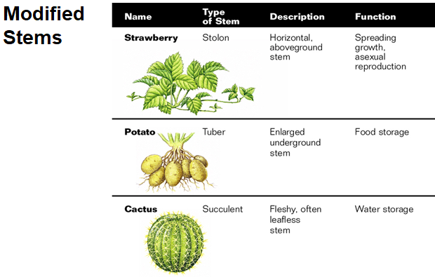

Describe the structure of leaves:
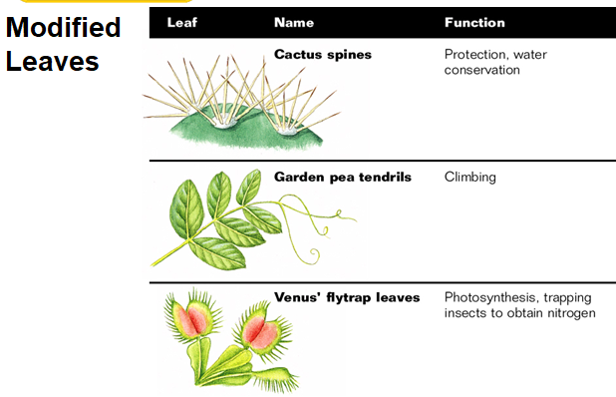
Leaves that only have one blade are called simple leaves.
Leaves are called compound leaves if they have a blade divided into leaflets
Describe the function and structure of roots
When a seed sprouts, it produces a primary root. If this first root becomes the largest root, it is called a taproot.
In some plants, the primary root does not become large. Instead, numerous small roots develop and branch to produce a fibrous root system
Describe the following properties of water
- Cohesion: water molecules attach to each other
- Adhesion: water molecules attach to objects
- Polarity: Hydrogen is + Oxygen is – thus attracting each other
- Surface tension: when small objects are able to float in water
- Capillary action: water molecules are drawn up through small spaces
Compare monocot and dicot plants
-type of roots
-number of seed leaves
-Leaf venation -number of flower plants

Describe the process of photosynthesis:
-Light dependent reaction:
The light reaction consists mainly of the conversion of H2O into O2 with the help of light, ATP, and NADP+ . This part of photosynthesis takes place in the membranes of small sacs found in the chloroplast called thylakoids.
The overall electron path is:
1. from water
2. to photosystem II (chlorophyll A)
3. down the photosystem II electron transport chain
4. to photosystem I (cholophyll A)
5. either down the photosystem II electron transport chain and back to NADPH

-Light independent reaction (Calvin Cycle)
The dark reactions include the making of glucose (C6H12O6) and water from CO2, ATP, and NADPH. In this reaction, 3 CO2 are mixed together with 3 molecules of ribulose bisphosphate ( RuBP: a five carbon sugar) to make 6 molecules of glucose-3-phosphate (G3P). This is the actual product of the dark reaction. ATP and NADPH are used as energy sources in this reaction and are changed back into ADP and NADP+ . They then are recycled to the light reactions. Water is also produced in this process
