Test Review

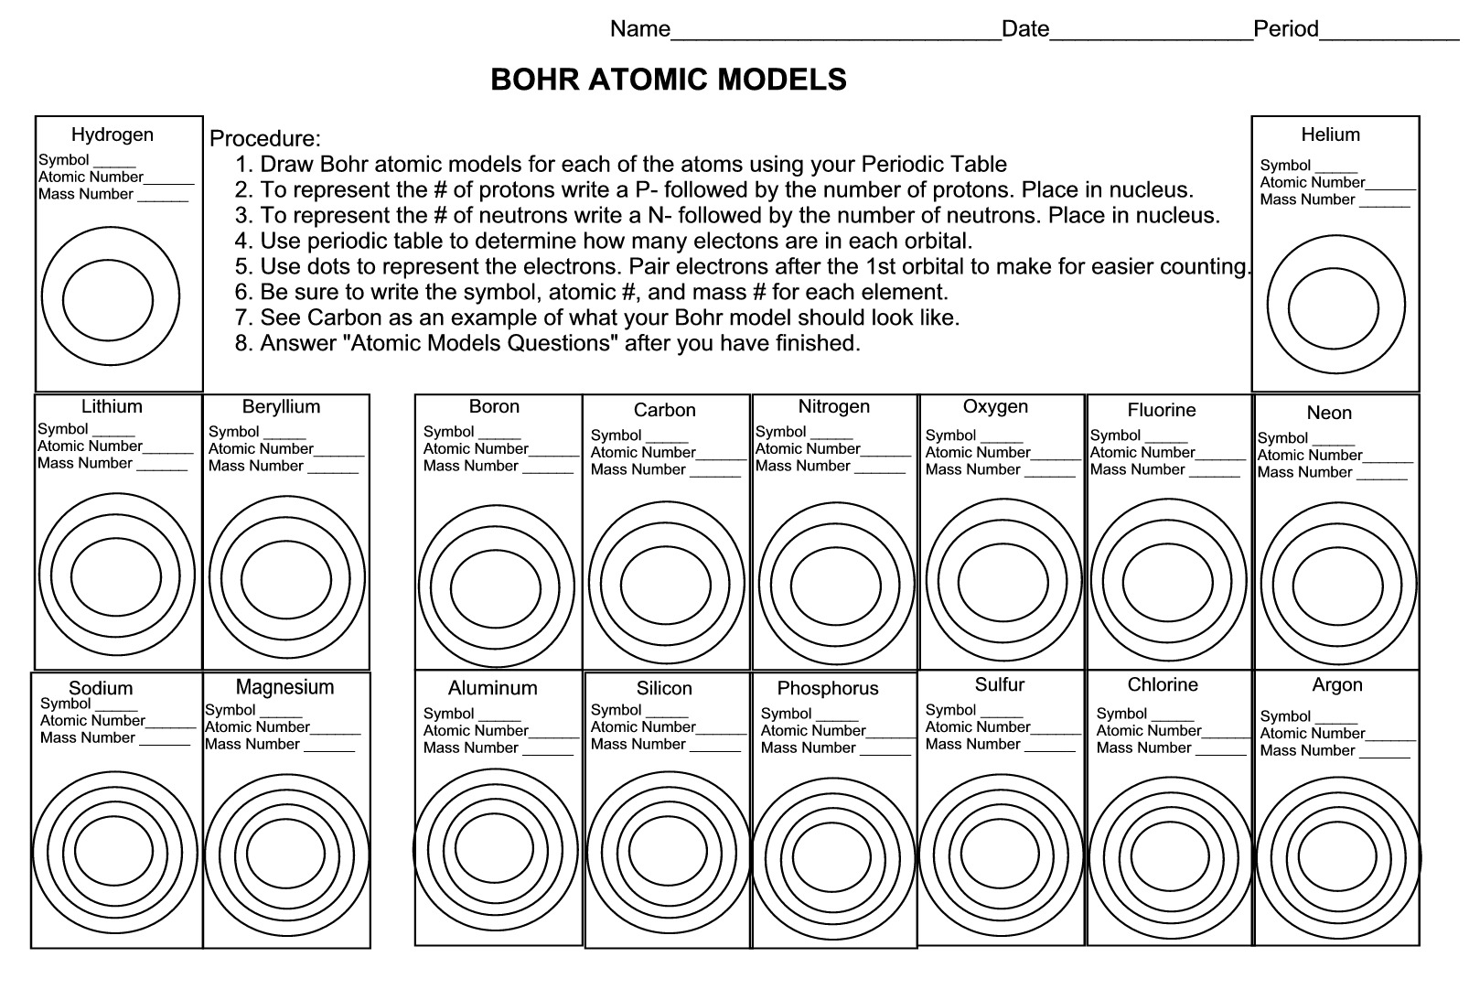
Write the Lewis Structure for the elements on above
Describe the Main events in the development of the atomic model:
Explain who discovered the following structures and the time:
Atom:
Electron:
Nucleus:
Protons:
Fill up the table below:
